**DAILY ONLINE ACTIVITIES SUMMARY**

|  |  |  |  |  |  |  |  |
| --- | --- | --- | --- | --- | --- | --- | --- |
| **Date:** | **20/05/2020** | | | | **Name:** | **Churashma** | |
| **Sem & Sec** | **4th SEM 'A' Section** | | | | **USN:** | **4AL18CS019** | |
| **Online Test Summary** | | | | | | | |
| **Subject** | | **Object oriented concepts** | | | | | |
| **Max. Marks** | | **30** | | **Score** | | **18** | |
| **Certification Course Summary** | | | | | | | |
| **Course** | **Introduction to digital marketing** | | | | | | |
| **Certificate Provider** | | | **greatlearning academy** | **Duration** | | | **1.5 hours** |
| **Coding Challenges** | | | | | | | |
| **Problem statement 1:**Given an array a[] of size n which contains elements from 0 to n-1, write a program printDuplicates which prints the duplicate elements of the given array. If no duplicate element is found print -1.  **Problem statement 2:**Write a C or Java program to implement FCFS and SJF process scheduling.  **Problem statement 3:Test** Case 1:  If a linked listis: 1 → 2 → 3 → 4 → 5 → 6 → 7 → 8  The value of size k is 2  Then the linked list looks like: 2 → 1 → 4 → 3 → 6 → 5 → 8 → 7  Test Case 2:  If a linked listis: 1 → 2 → 3 → 4 → 5 → 6 → 7 → 8  The value of size k is 3  Then the linked list looks like: 3 → 2 → 1 → 6 → 5 → 4 → 8 → 7 | | | | | | | |
| **Status: completed** | | | | | | | |
| **Uploaded the report in Github** | | | | **yes** | | | |
| **If yes Repository name** | | | | **https://github.com/Churashma/Lockdown-coding** | | | |
| **Uploaded the report in slack** | | | | **yes** | | | |

ONLINE TEST DETAILS:

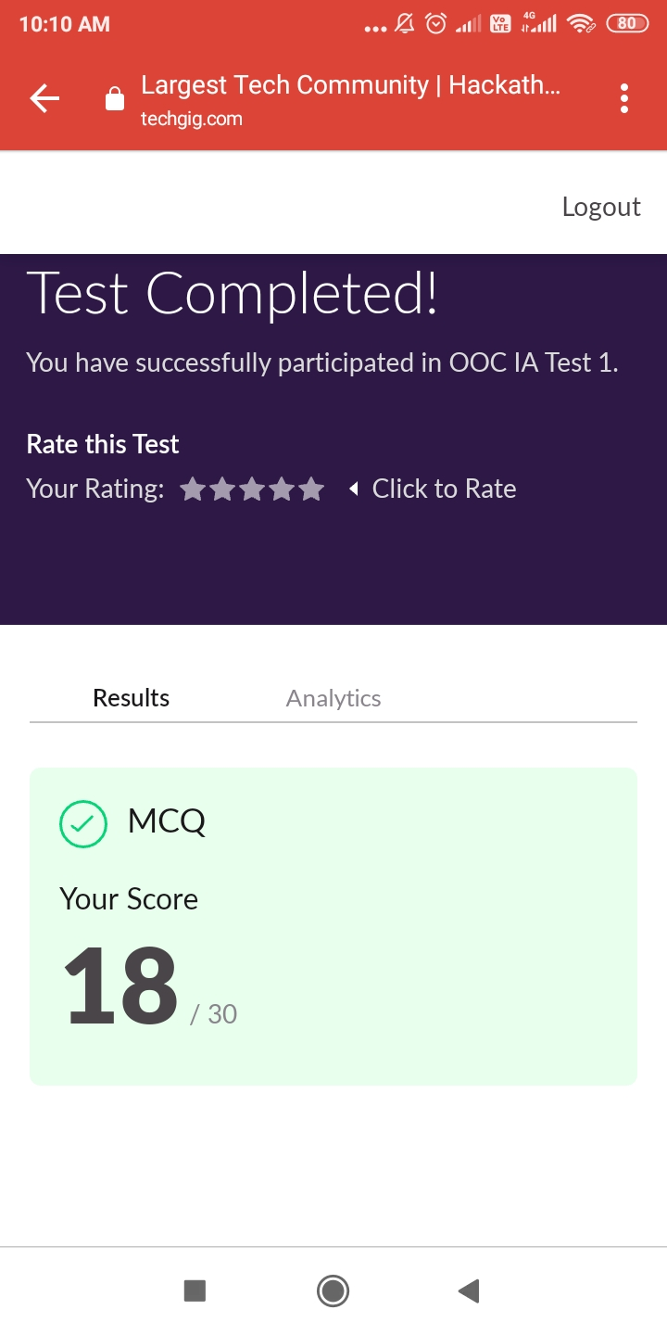

CERTIFICATION COURSE DETAILS:

Introduction to digital marketing : Digital marketing is a field of marketing that uses the internet and online digital technologies to promote products and services. This course is for anyone who is curious about Digital Marketing and wants to learn more about digital marketing strategies and how to run ads on various marketing channels.

The course focuses on

* Consumer-centric approach to business
* Explanation of New Medias
* Understanding Brand Purpose
* Facebook 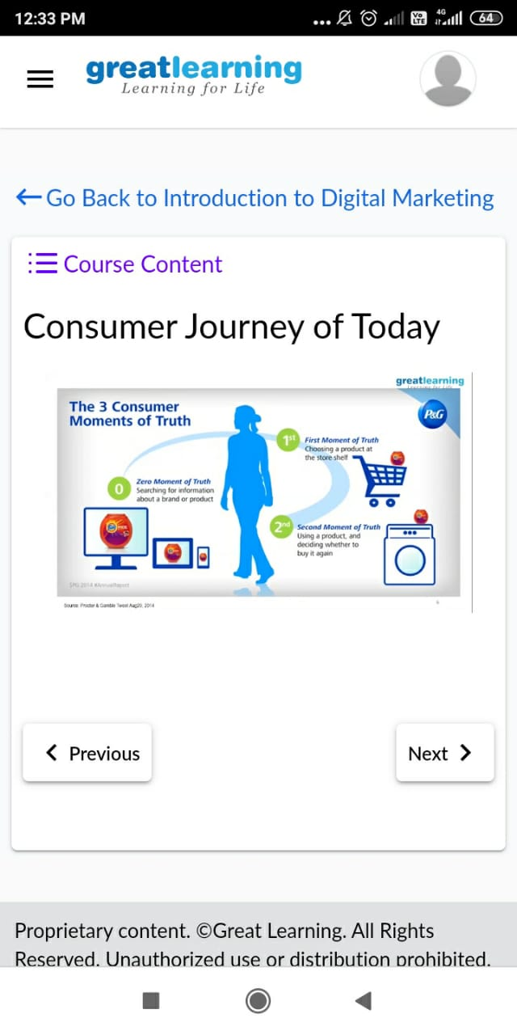Marketing

**CODING CHALLENGES DETAILS**:

**Problem statement 1:**

Given an array a[] of size n which contains elements from 0 to n-1, write a program printDuplicates which prints the duplicate elements of the given array. If no duplicate element is found print -1.  
Input:  
The first line of input must contains an integer n which denotes number of elements of Array. Second line contains n space separated integers denoting elements of array a[].

Output:Print the duplicate elements from the given array.

Solution : Uploaded it in github

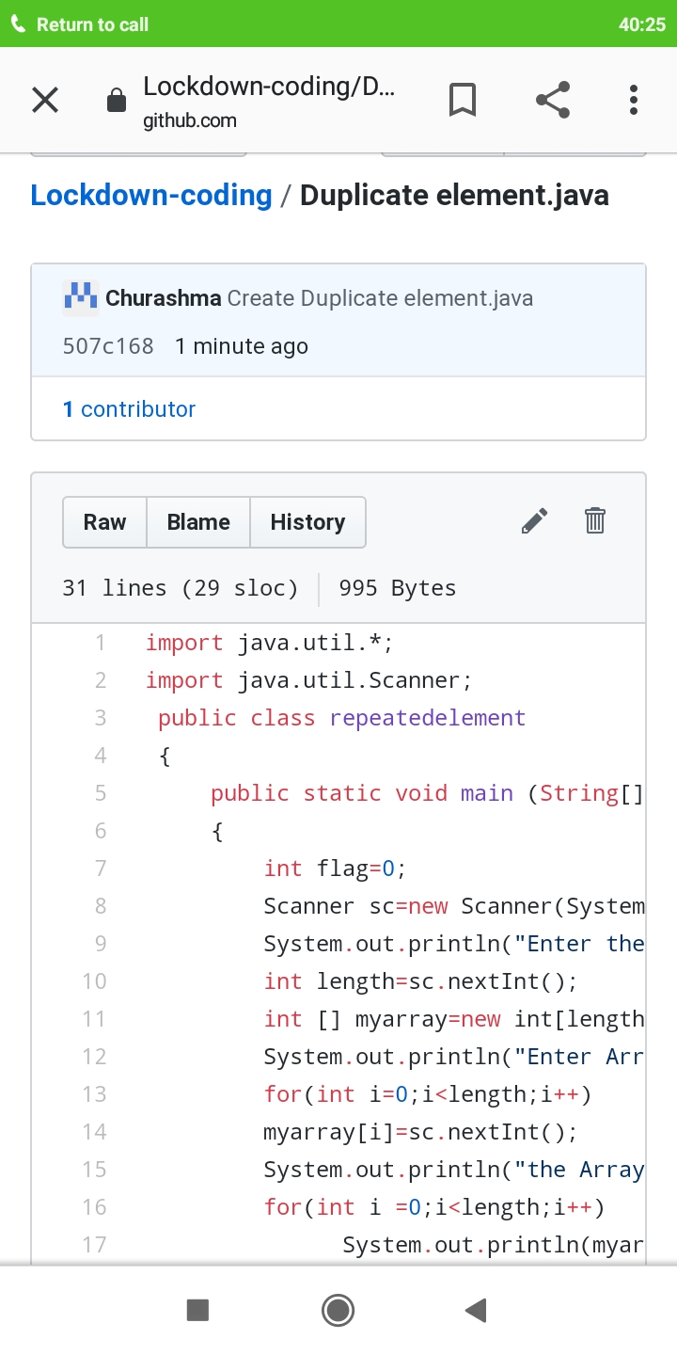

**Problem statement 2**

Write a C or Java program to implement FCFS and SJF process scheduling.

Input: Processes with burst time

Output: Process being scheduled

Solution: Uploaded in github.

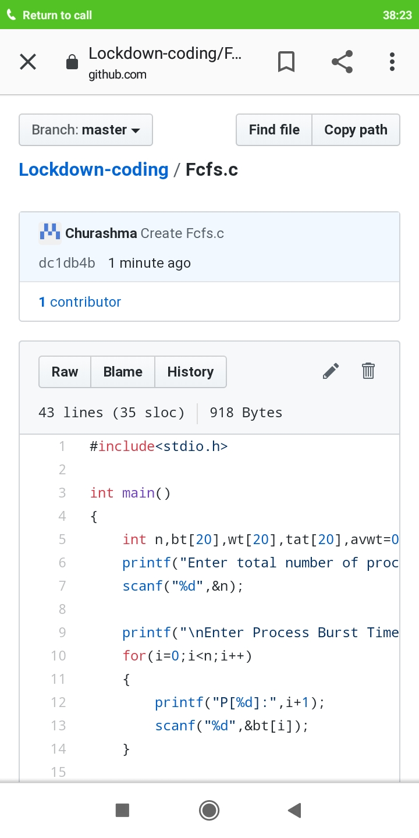

**Problem statement 3**

Write a c program to reverse a sll

Test Case 1:

If a linked listis: 1 → 2 → 3 → 4 → 5 → 6 → 7 → 8

The value of size k is 2

Then the linked list looks like: 2 → 1 → 4 → 3 → 6 → 5 → 8 → 7

Test Case 2:

If a linked listis: 1 → 2 → 3 → 4 → 5 → 6 → 7 → 8

The value of size k is 3

Then the linked list looks like: 3 → 2 → 1 → 6 → 5 → 4 → 8 → 7

